## Front End Engineering-II /Artificial

## Intelligence and Machine Learning

Project Report

Semester-IV (Batch-2022)

Title of the Project-

Face Recognition System

**Supervised By: Submitted By:**

Faculty Name Manya Jain (2210990563)

Mr. Shubham Singhal Manan Magu (2210990552)

Namit Gulati (2210990595)

Lovisha Bansal (2210990546)

**Department of Computer Science and Engineering**

**Chitkara University Institute of Engineering & Technology, Chitkara University, Punjab**

**ABSTRACT**

Face recognition technology has witnessed significant advancements in recent years, driven by the rapid progress of deep learning algorithms and the increasing availability of large-scale datasets. This project explores the historical evolution, key components, processes, applications, challenges, and future directions of face recognition systems.

The historical evolution traces the development of face recognition from early manual methods to modern deep learning-based approaches. Key components and processes encompass face detection, feature extraction, and recognition algorithms, highlighting the technical intricacies involved in accurate identification.

Applications of face recognition span various domains, including security, surveillance, authentication, and personalized services, showcasing its versatility and potential societal impact. However, challenges such as accuracy, privacy concerns, bias mitigation, and regulatory compliance pose significant hurdles to widespread adoption.

Current trends emphasize advancements in deep learning architectures, real-time processing, privacy-enhancing technologies, and multi-modal biometrics. Future directions focus on enhancing accuracy, privacy, fairness, and usability, while addressing emerging challenges and regulatory requirements.

By addressing these aspects comprehensively, this project aims to provide a holistic understanding of face recognition technology, its current capabilities, and future prospects, contributing to its responsible development and ethical deployment in society.

Security has become a major issue globally and in order to manage the security challenges and reduce the security risks in the world, biometric systems such as face detection and recognition systems have been built.

These systems are capable of providing biometric security, crime prevention and video surveillance services because of their inbuilt verification and identification capabilities. This has become possible due to technological advancement in the fields of automated face analysis, machine learning and pattern recognition. biometric and facial recognition techniques. In this research paper, we review some advance

For this, Viola-Jones Algorithm, Local Binary Pattern Histogram Algorithm and Neural Network Plays a major role. There are lot of machine learning and image processing library.

This report is mainly based on OpenCV and NumPy i.e., a model is created using these libraries. To create model, dataset (labelled data) is required which is generated using OpenCV and for visualization of output, another dataset (without labelling) is generated and this time, a model predicted the label (i.e., name) of that image

**Ethical Considerations and Societal Impact**: Face recognition technology raises important ethical considerations regarding privacy, surveillance, and individual rights. This project explores the ethical implications of widespread face recognition deployment, including issues of consent, data protection, and potential misuse. Additionally, it examines the societal impact of face recognition systems on various demographic groups, highlighting the importance of fairness, equity, and social responsibility in technology development and deployment.

**Interdisciplinary Perspectives and Collaborative Efforts**: Face recognition technology draws upon expertise from diverse fields such as computer vision, machine learning, psychology, and ethics. This project emphasizes the interdisciplinary nature of face recognition research and the importance of collaborative efforts between researchers, policymakers, industry stakeholders, and civil society organizations. By fostering collaboration and dialogue across disciplines, this project aims to promote a holistic understanding of face recognition technology and its implications for society.

**Table of contents:**

**1.Introduction**

**1.1 Background**

**1.2 Objectives**

**1.3 Significance**

**2. Problem Definition and Requirements**

**2.1 Problem statement**

**2.2 Software requirement**

**2.3 Hardware requirement**

**2.4 Data Sets**

**3. Proposed Design / Methodology**

**3.1 Schematic Diagram**

**3.2 File structure**

**3.3 Algorithm used**

**4. Results**

**4.1 Screenshots**

**4.2 Metrics**

**5. References**

**Introduction:**

* Face recognition has gained tremendous attention over the last three decades since it is considered a simplified image analysis and pattern recognition application.
* There are at least two reasons for understanding this trend: (1) the large variety of commercial and legal requests, besides (2) the availability of the relevant technologies (e.g., smartphones, digital cameras, GPU, ...).
* Although the existing machine learning/recognition systems have achieved some degree of maturity, their performance is limited to the conditions imposed in real-world applications.
* Today facial recognition, associated with artificial intelligence techniques, enables a person to be identified from his face or verified as what he claims to be. Facial recognition can analyze facial features and other biometric details, such as the eyes, and compare them with photographs or videos.
* Face recognition is a technology that identifies or verifies a person from a digital image or video frame from a video source. It is one of the most successful applications of image analysis and understanding, driven significantly by advances in deep learning (DL).
* This technology has numerous applications, ranging from security and surveillance to user authentication and social media tagging.

**Introduction**

**1.1 Background**

1. Introduction to Facial Recognition Systems

Facial recognition systems are a subset of biometric technology that aim to identify or verify individuals based on their facial features. This technology has gained significant traction in recent years due to its potential applications in various domains, including security, surveillance, access control, and personalized services. Face recognition is a technology that identifies or verifies a person from a digital image or video frame from a video source. It is one of the most successful applications of image analysis and understanding, driven significantly by advances in deep learning (DL). This technology has numerous applications, ranging from security and surveillance to user authentication and social media tagging.

1. Historical Evolution

The roots of facial recognition technology can be traced back to the 1960s, with early experiments focusing on facial feature extraction and pattern recognition. Significant progress has been made since then, driven by advancements in computer vision, machine learning, and artificial intelligence.

The journey of face recognition technology spans several decades, evolving from simple manual methods to advanced deep learning techniques. This evolution reflects the broader advancements in computing power, image processing, and artificial intelligence.

#### 1960s: The Beginnings

1. **Manual Measurements**: The early work on face recognition involved manual measurements of facial features like the distance between eyes, nose width, and mouth shape. These measurements were then used for identification purposes.
2. **Woody Bledsoe**: One of the pioneers in the 1960s, Woody Bledsoe, along with Helen Chan Wolf and Charles Bisson, developed some of the first semi-automated face recognition systems. These systems required the operator to manually locate features such as the eyes, ears, nose, and mouth on photographs.

#### 1970s: Feature-Based Approaches

1. **Component Analysis**: During the 1970s, researchers began focusing on automated systems that could recognize facial features. This era saw the development of algorithms that could detect and measure facial components automatically.
2. **Pattern Recognition**: Techniques from pattern recognition started being applied to facial recognition tasks. This included the use of edge detection and basic machine learning algorithms.

#### 1980s: Introduction of PCA

1. **Eigenfaces**: In 1988, Kirby and Sirovich introduced the concept of eigenfaces, a breakthrough in face recognition. This approach used Principal Component Analysis (PCA) to reduce the dimensionality of face images and represent them as a combination of eigenfaces.
2. **Matthew Turk and Alex Pentland**: Building on this, in 1991, Turk and Pentland from MIT developed a face recognition system using eigenfaces, which became a seminal work in the field.

#### 1990s: Statistical Models and Improved Algorithms

1. **Fisherfaces and LDA**: In the mid-1990s, the use of Linear Discriminant Analysis (LDA) led to the development of Fisherfaces. This approach improved recognition rates by maximizing the ratio of between-class variance to within-class variance in face data.
2. **Elastic Bunch Graph Matching**: This method, developed by Lades et al. in 1993, used dynamic link architecture to model faces using graphs and bunch graphs. This technique captured both the facial geometry and texture.

#### 2000s: SIFT and 3D Face Recognition

1. **SIFT (Scale-Invariant Feature Transform)**: David Lowe introduced SIFT in 1999, which became widely used in the early 2000s for object recognition, including faces. SIFT features are invariant to scale and rotation, making them robust for face recognition.
2. **3D Face Recognition**: The availability of 3D scanning technology led to the development of 3D face recognition systems. These systems captured the geometry of a face, providing more accurate recognition under varying lighting and pose conditions.

#### 2010s: The Deep Learning Revolution

1. **Deep Learning**: The 2010s saw the rise of deep learning, which revolutionized face recognition. Convolutional Neural Networks (CNNs) became the backbone of most face recognition systems.
2. **DeepFace**: In 2014, Facebook's DeepFace project achieved near-human-level performance in face verification tasks. DeepFace used deep neural networks to learn face representations from millions of labeled images.
3. **FaceNet**: Google's FaceNet, introduced in 2015, further pushed the boundaries by mapping faces to a Euclidean space such that the distance between faces corresponded to their similarity. FaceNet used a triplet loss function for training, improving recognition accuracy significantly.

#### 2020s: Advancements and Ethical Considerations

1. **State-of-the-Art Models**: The 2020s continue to see advancements in face recognition technologies, with models achieving even higher accuracy and robustness. Techniques like attention mechanisms, transformers, and generative adversarial networks (GANs) are being integrated into face recognition systems.
2. **Ethical and Privacy Issues**: As face recognition technology becomes more widespread, concerns about privacy, surveillance, and bias have grown. This period has seen increasing calls for regulation and the development of fair and unbiased face recognition systems.

#### Future Directions

1. **Bias Mitigation**: Future research is focusing on mitigating biases in face recognition systems to ensure fair treatment across different demographic groups.
2. **Privacy-Preserving Techniques**: Techniques such as federated learning and homomorphic encryption are being explored to develop privacy-preserving face recognition systems.
3. **Multimodal Recognition**: Combining face recognition with other biometric modalities like voice and gait recognition for improved accuracy and robustness.

The evolution of face recognition technology reflects a broader trend in artificial intelligence and machine learning, moving from simple manual techniques to complex automated systems powered by deep learning. As the technology continues to advance, it brings both significant opportunities and challenges that need to be addressed through ongoing research and ethical considerations.

Top of Form

1. Key Components and Processes

Facial recognition systems typically consist of three main stages: face detection, feature extraction, and matching. Face detection algorithms identify and locate faces within images or video frames, while feature extraction techniques analyze key facial characteristics such as the distance between eyes, nose shape, and jawline. Matching algorithms compare these features against a database of known faces to identify or verify individuals.

Face recognition technology involves several critical components and processes that work together to identify or verify individuals from images or video frames. These components are Detection, Alignment, Feature Extraction, and Recognition. Each stage plays a crucial role in ensuring accurate and efficient face recognition.

#### 1. Face Detection

**Definition**: Face detection is the process of identifying and locating human faces in an image or video. It serves as the first step in face recognition systems.

**Methods**:

* **Traditional Methods**: Earlier methods, such as the Viola-Jones detector, used Haar-like features and AdaBoost for real-time face detection. These methods are fast but less accurate in varied lighting conditions and complex backgrounds.
* **Deep Learning Approaches**: Modern face detection leverages convolutional neural networks (CNNs). Examples include the Single Shot Multibox Detector (SSD) and Multi-task Cascaded Convolutional Networks (MTCNN). These models offer higher accuracy and robustness, handling variations in pose, illumination, and occlusion effectively.

**Key Points**:

* **Real-Time Detection**: Essential for applications like surveillance and authentication.
* **Robustness**: Effective face detection must handle diverse conditions such as different lighting, angles, and facial expressions.

#### 2. Face Alignment

**Definition**: Face alignment involves standardizing the orientation and size of detected faces to ensure consistency in the subsequent feature extraction process.

**Methods**:

* **Landmark Localization**: Detecting key facial landmarks (e.g., eyes, nose, mouth) and aligning the face based on these points. Techniques like Active Shape Models (ASM) and Active Appearance Models (AAM) were early approaches.
* **Deep Learning-Based Alignment**: Modern techniques use CNNs to detect landmarks more accurately. For example, the Dlib library utilizes a deep learning-based facial landmark detector to align faces.

**Key Points**:

* **Normalization**: Aligning faces to a common coordinate system to reduce variability.
* **Improvement in Recognition**: Proper alignment significantly enhances the performance of feature extraction and recognition stages.

#### 3. Feature Extraction

**Definition**: Feature extraction involves transforming the aligned face into a numerical representation that captures the essential characteristics of the face.

**Methods**:

* **Traditional Approaches**: Methods like Local Binary Patterns (LBP), Scale-Invariant Feature Transform (SIFT), and Histogram of Oriented Gradients (HOG) were used to extract features based on texture and shape.
* **Deep Learning-Based Methods**: CNNs have revolutionized feature extraction. Models like VGG-Face, ResNet, and Inception are pre-trained on large datasets and fine-tuned for face recognition tasks. These models learn high-dimensional feature representations that are robust to variations in pose, lighting, and expressions.

**Key Points**:

* **High-Dimensional Vectors**: Extracted features are typically high-dimensional vectors that uniquely represent the face.
* **Robustness and Accuracy**: Deep learning models provide superior feature extraction capabilities compared to traditional methods.

#### 4. Face Recognition (Identification and Verification)

**Definition**: Face recognition involves matching extracted features against a database to either identify or verify a person's identity.

**Methods**:

* **Identification**: Involves matching the extracted features of an unknown face against a database of known faces to find the closest match. This is often used in security and surveillance systems.
* **Verification**: Involves comparing the extracted features of a face with a claimed identity to verify if they match. This is commonly used in authentication systems.

**Techniques**:

* **Distance Metrics**: Techniques like Euclidean distance, cosine similarity, and Mahalanobis distance are used to compare feature vectors. Models like FaceNet use these metrics in conjunction with triplet loss to optimize the recognition process.
* **Classification Algorithms**: Support Vector Machines (SVM), k-Nearest Neighbors (k-NN), and decision trees can also be used to classify feature vectors.

**Key Points**:

* **Accuracy**: The recognition system's accuracy depends on the quality of feature extraction and the robustness of the matching algorithm.
* **Scalability**: Effective face recognition systems must handle large databases and perform real-time recognition.

Face recognition technology relies on a series of interconnected processes and components. Face detection identifies and locates faces, alignment standardizes their orientation, feature extraction transforms them into numerical representations, and recognition matches these features against a database. Advancements in deep learning have significantly enhanced the accuracy and robustness of each of these stages, making face recognition a powerful tool in various applications from security to personal device authentication.

Top of Form

1. Applications

Facial recognition systems have a wide range of applications across various industries. In the realm of security and surveillance, these systems are used for monitoring public spaces, identifying criminals, and enhancing border control measures. Additionally, facial recognition technology is employed for access control in buildings, airports, and electronic devices. In the retail sector, it enables personalized advertising and customer analytics based on demographic information.

Face recognition technology has become ubiquitous across various industries due to its ability to accurately and efficiently identify individuals. Its applications span security, finance, healthcare, retail, and entertainment, among other sectors. Below are some of the primary applications of face recognition technology.

#### 1. Security and Surveillance

**Public Safety**: Face recognition systems are widely used in public spaces like airports, train stations, and stadiums to enhance security. They help in identifying and tracking individuals of interest, including criminals and missing persons, thus improving public safety.

**Access Control**: In secure facilities such as government buildings, corporate offices, and military bases, face recognition is used for access control. It ensures that only authorized personnel can enter restricted areas.

**Law Enforcement**: Police departments use face recognition to compare surveillance footage with databases of known criminals. This aids in quickly identifying and apprehending suspects.

#### 2. Authentication and Access Control

**Smartphones and Personal Devices**: Many smartphones and laptops now come equipped with face recognition for user authentication. This provides a convenient and secure way to unlock devices without the need for passwords or PINs.

**Financial Services**: Banks and financial institutions use face recognition for secure customer authentication during transactions. This includes online banking, ATM withdrawals, and entry to secure areas.

**Smart Homes**: Face recognition is integrated into smart home systems to enhance security and personalize user experiences. For example, it can be used to unlock doors, adjust settings, and provide access to specific features for recognized users.

#### 3. Retail and E-commerce

**Customer Experience**: Retail stores use face recognition to identify loyal customers and personalize their shopping experience. This can include personalized greetings, customized recommendations, and tailored promotions.

**Security**: Face recognition helps in reducing theft and fraud in retail environments by identifying known shoplifters or individuals with a history of fraudulent activity.

**Payments**: Some e-commerce platforms and physical stores have started using face recognition for payment authentication, providing a seamless and secure checkout process.

#### 4. Healthcare

**Patient Identification**: Hospitals and clinics use face recognition to accurately identify patients, ensuring that the correct treatments are administered to the right individuals. This reduces errors and improves patient safety.

**Access to Medical Records**: Face recognition can secure access to sensitive medical records, allowing only authorized personnel to retrieve patient information.

**Monitoring and Support**: In care facilities, face recognition helps monitor patients, particularly those with conditions like Alzheimer's, ensuring they receive timely assistance and support.

#### 5. Education

**Attendance Monitoring**: Schools and universities use face recognition to automate attendance tracking. This saves time and ensures accurate records of student attendance.

**Campus Security**: Face recognition systems help enhance campus security by monitoring entry points and identifying unauthorized individuals.

**Personalized Learning**: Educational software can use face recognition to adapt content delivery based on student engagement and emotional responses, providing a more personalized learning experience.

#### 6. Entertainment and Social Media

**Photo Tagging**: Social media platforms like Facebook use face recognition to suggest tags in photos, making it easier for users to identify and organize their pictures.

**Access to Content**: Face recognition can control access to age-restricted or personalized content on streaming services and gaming platforms.

**Augmented Reality (AR)**: AR applications use face recognition to overlay digital content on real-world images. This includes facial filters on social media apps and virtual try-ons for makeup or eyewear.

#### 7. Transportation

**Passenger Identification**: Airports and airlines use face recognition for passenger identification during check-in, security checks, and boarding, streamlining the travel process.

**Driver Authentication**: Ride-sharing companies and taxi services use face recognition to verify drivers' identities, enhancing passenger safety.

**Access Control in Vehicles**: Automotive manufacturers integrate face recognition into vehicles to personalize settings and provide secure access to the car.

#### 8. Workforce Management

**Employee Attendance**: Companies use face recognition to automate and secure employee attendance systems, reducing the risk of time theft and ensuring accurate payroll processing.

**Security and Access**: Face recognition controls access to sensitive areas within workplaces, ensuring that only authorized employees can enter.

**Productivity Monitoring**: Some organizations use face recognition to monitor employee engagement and productivity, although this application raises significant privacy concerns.

Face recognition technology has a broad spectrum of applications across various domains, driven by its ability to provide secure, efficient, and user-friendly solutions. As the technology continues to advance, its adoption is expected to grow, bringing both opportunities and challenges. The key to its successful implementation lies in balancing the benefits with ethical considerations, particularly regarding privacy and bias.

Top of Form

Bottom of Form

1. Challenges and Concerns

Despite its potential benefits, facial recognition technology also presents several challenges and concerns. Issues such as algorithmic bias, privacy violations, and potential misuse have raised ethical and legal questions surrounding its deployment. Moreover, the accuracy of facial recognition systems can be affected by factors such as lighting conditions, occlusions, and variations in facial expressions.

While face recognition technology offers numerous benefits and applications, it also faces several significant challenges and concerns. These issues span technical, ethical, and legal domains, impacting the effectiveness and acceptance of the technology.

#### 1. Technical Challenges

**Variability in Conditions**:

* **Lighting**: Changes in lighting conditions can significantly affect the accuracy of face recognition systems. Poor lighting can obscure facial features, while harsh lighting can create shadows, both of which reduce recognition accuracy.
* **Pose Variation**: Different angles and orientations of the face can challenge the system. Profiles, tilted faces, and other non-frontal poses require robust algorithms to maintain accuracy.
* **Occlusions**: Accessories like glasses, hats, masks, or even facial hair can obstruct key facial features, complicating the recognition process.

**Aging**: Faces change over time due to aging, which can affect the performance of face recognition systems. Regular updates to the facial database are necessary to maintain accuracy.

**Resolution**: Low-resolution images, such as those from surveillance cameras, can hinder the system's ability to accurately identify individuals. High-resolution images provide more detailed features for recognition but are not always available.

**Scalability**: As the size of the database increases, the system must handle more comparisons, which can slow down the process and reduce efficiency. Ensuring quick and accurate recognition in large-scale systems is a technical challenge.

#### 2. Ethical and Privacy Concerns

**Surveillance and Privacy**:

* **Mass Surveillance**: The use of face recognition for mass surveillance raises significant privacy issues. Individuals may be monitored without their consent, leading to a potential invasion of privacy.
* **Data Security**: The storage and handling of facial data must be secure to prevent unauthorized access and misuse. Breaches can lead to identity theft and other privacy violations.

**Bias and Fairness**:

* **Algorithmic Bias**: Face recognition systems can exhibit biases based on the demographic makeup of their training data. Studies have shown that these systems often perform less accurately for people of color, women, and other minority groups, leading to unfair and discriminatory outcomes.
* **Discrimination**: Biased algorithms can result in higher rates of false positives or false negatives for certain demographic groups, leading to potential discrimination in applications like law enforcement and hiring.

**Consent and Transparency**:

* **Informed Consent**: Individuals should be informed and provide consent before their facial data is collected and used. Lack of transparency can lead to misuse and erosion of trust.
* **Transparency**: Organizations using face recognition must be transparent about how the technology is used, the data collected, and the measures taken to protect privacy and prevent misuse.

#### 3. Legal and Regulatory Challenges

**Regulation**:

* **Lack of Standards**: There is currently a lack of standardized regulations governing the use of face recognition technology. This leads to inconsistent practices and potential misuse.
* **Evolving Laws**: The legal landscape is rapidly evolving, with new laws and regulations being proposed and enacted. Organizations must stay updated and compliant with these changes, which can be complex and resource-intensive.

**Accountability**:

* **Responsibility for Errors**: Determining who is accountable for errors made by face recognition systems, such as false arrests or misidentification, is a complex issue. Clear guidelines and accountability measures are necessary to address this.
* **Ethical Use**: Organizations must ensure that face recognition is used ethically and responsibly, avoiding scenarios that could harm individuals or communities.

1. Current Trends and Future Directions

Recent advancements in deep learning, particularly convolutional neural networks (CNNs), have significantly improved the performance of facial recognition systems. These developments have led to greater accuracy, robustness, and scalability, paving the way for broader adoption in both commercial and governmental settings. Looking ahead, ongoing research efforts focus on addressing remaining challenges and exploring new applications, such as emotion recognition and facial expression analysis.

This structured background provides readers with a comprehensive overview of the development, applications, challenges, and future prospects of facial recognition systems. Face recognition technology continues to evolve rapidly, driven by advancements in artificial intelligence, increased computational power, and expanding applications across various industries. The current trends reflect efforts to improve accuracy, address ethical concerns, and expand the utility of the technology. Future directions indicate a trajectory towards more sophisticated, secure, and ethical implementations.

#### Current Trends

**1. Deep Learning Advancements**

* **Improved Architectures**: Innovations in deep learning architectures, such as convolutional neural networks (CNNs), recurrent neural networks (RNNs), and transformers, have significantly enhanced the accuracy and robustness of face recognition systems.
* **Pre-trained Models**: The use of pre-trained models like VGGFace, FaceNet, and OpenFace allows for more efficient training and deployment, leveraging vast datasets for improved performance.

**2. Real-Time Recognition**

* **Edge Computing**: Implementing face recognition on edge devices, such as smartphones and IoT devices, enables real-time processing and reduces latency. This trend is particularly important for applications in security and consumer electronics.
* **Cloud Integration**: Cloud-based face recognition services offer scalable solutions for businesses, providing powerful processing capabilities and seamless integration with existing systems.

**3. Enhanced Security and Privacy**

* **Federated Learning**: This approach allows models to be trained across multiple decentralized devices without sharing raw data, enhancing privacy and security.
* **Differential Privacy**: Techniques that add noise to data, ensuring that individual privacy is protected while still allowing useful patterns to be learned, are becoming more common.

**4. Bias Mitigation**

* **Fairness-Aware Algorithms**: Research is increasingly focused on developing algorithms that are less biased and fairer across different demographic groups. Techniques include balanced training data, bias detection tools, and fairness-aware modeling.
* **Regulation Compliance**: Companies are actively working to comply with new regulations that mandate the reduction of bias and enhancement of fairness in AI systems.

**5. Multi-Modal Biometrics**

* **Integration with Other Biometrics**: Combining face recognition with other biometric modalities like fingerprint, iris, and voice recognition enhances the accuracy and security of identification systems.
* **Behavioral Biometrics**: Analyzing patterns in user behavior, such as typing rhythm or gait, alongside facial features, provides additional layers of security and personalization.

#### Future Directions

**. Privacy-Enhancing Technologies**

* **Homomorphic Encryption**: This allows computations to be performed on encrypted data without decrypting it, offering strong privacy protections for face recognition applications.
* **Zero-Knowledge Proofs**: These cryptographic methods enable one party to prove to another that they know a value without revealing the value itself, potentially enhancing the security of face recognition systems.

**. Regulation and Ethical Guidelines**

* **Global Standards**: The development of international standards and best practices for the ethical use of face recognition technology will be crucial. These standards will likely address privacy, bias, transparency, and accountability.
* **Ethical Frameworks**: Establishing ethical frameworks and guidelines for the development and deployment of face recognition technology will help ensure that it is used responsibly and for the benefit of society.

**1.2 Objectives**

The objectives typically revolve around leveraging machine learning algorithms to enhance the accuracy, efficiency, and robustness of facial recognition systems. Here are some common objectives for such a project:

When undertaking a face recognition project, defining clear and precise objectives is crucial for guiding the development process, ensuring the system meets its intended goals, and addressing both technical and ethical considerations. Here are key objectives typically outlined for face recognition projects:

#### 1. Accuracy and Reliability

**High Recognition Accuracy**: Develop a system that can accurately identify or verify individuals with high precision, minimizing both false positives and false negatives.

**Robustness to Variations**: Ensure the system performs well under different conditions, such as varying lighting, poses, facial expressions, and occlusions like glasses or hats.

**Aging and Temporal Stability**: Create a model that can recognize individuals despite changes over time, such as aging or minor alterations in appearance.

#### 2. Speed and Efficiency

**Real-Time Processing**: Design the system to operate in real-time, enabling quick recognition suitable for applications like surveillance, access control, and mobile devices.

**Low Computational Overhead**: Optimize the system to run efficiently on available hardware, whether it’s edge devices like smartphones or cloud-based servers, to ensure scalability and responsiveness.

**Scalability**: Develop a solution that can handle large databases and numerous simultaneous recognitions without significant degradation in performance.

#### 3. Security and Privacy

**Data Protection**: Implement strong data security measures to protect stored facial images and features, ensuring compliance with data protection regulations.

**Privacy Preservation**: Incorporate techniques such as anonymization, encryption, and differential privacy to safeguard individual identities and personal information.

**Ethical Use**: Ensure the technology is used ethically, with transparent policies on data usage, consent, and purpose to maintain public trust.

#### . Bias Mitigation and Fairness

**Bias Detection and Reduction**: Develop methods to detect and mitigate biases in the face recognition system, ensuring fair and equitable performance across different demographic groups.

**Diverse Training Data**: Use diverse and representative datasets during training to improve the model’s fairness and accuracy for all population segments.

**Regular Audits**: Conduct regular audits of the system to identify and address any emerging biases or performance issues across different demographics.

#### 5. Integration and Usability

**Seamless Integration**: Design the system to integrate easily with existing infrastructure and applications, such as security systems, mobile apps, and databases.

**User-Friendly Interface**: Create an intuitive user interface for both end-users and administrators, making the system easy to use, configure, and maintain.

**Adaptability and Customization**: Allow for customization to meet specific requirements of different applications and environments, from corporate security to consumer electronics.

By addressing these objectives, a machine learning project focused on facial recognition aims to develop advanced algorithms and techniques that improve the accuracy, efficiency, fairness, and usability of facial recognition systems, ultimately enabling their widespread adoption and positive impact in various domains.

**1.3 Significance**

The significance of a machine learning project focused on facial recognition lies in its potential to address real-world challenges, unlock new opportunities, and contribute to various fields. Here are some key aspects highlighting the significance of such a project

Face recognition technology has emerged as a transformative tool with significant implications across various sectors. Its importance is underscored by its ability to enhance security, improve user experiences, streamline processes, and foster innovations. Here are key points highlighting the significance of face recognition technology:

#### 1. Enhanced Security and Public Safety

**Crime Prevention and Detection**:

* **Law Enforcement**: Face recognition aids in identifying and apprehending criminals by matching surveillance footage with databases of known offenders. This enhances the ability of law enforcement agencies to solve crimes more efficiently.
* **Terrorism Prevention**: Airports, borders, and critical infrastructure utilize face recognition to identify potential terrorists and prevent attacks, thereby bolstering national security.

**Access Control**:

* **Restricted Areas**: Secure facilities such as government buildings, military bases, and corporate offices use face recognition to ensure only authorized individuals gain access, reducing the risk of unauthorized entry and insider threats.
* **Smart Devices**: Integration in smartphones and laptops for user authentication enhances device security, making it difficult for unauthorized users to access sensitive information.

#### 2. Improved User Experience

**Convenience and Speed**:

* **Contactless Authentication**: Face recognition provides a quick and contactless method of authentication, which is particularly valuable in situations where hygiene and convenience are paramount, such as during the COVID-19 pandemic.
* **Personalization**: Retail and hospitality industries use face recognition to deliver personalized services. For example, recognizing a customer as they enter a store can trigger personalized recommendations and offers.

**Seamless Transactions**:

* **Financial Services**: Banks and payment systems use face recognition to verify identities during transactions, enhancing security while simplifying the user experience.

#### 3. Efficiency and Cost Savings

**Automated Processes**:

* **Attendance Systems**: Educational institutions and workplaces use face recognition to automate attendance tracking, reducing manual errors and administrative overhead.
* **Border Control**: Automated border control systems, like e-gates, use face recognition to expedite the immigration process, reducing wait times and operational costs.

**Loss Prevention**:

* **Retail Security**: Face recognition helps in identifying shoplifters and preventing theft, leading to significant cost savings for retailers.

#### 4. Technological and Economic Impact

**Innovation Driver**:

* **AI and Machine Learning**: Face recognition technology is at the forefront of advancements in artificial intelligence and machine learning, driving research and development in these fields.
* **Industry Growth**: The face recognition market is growing rapidly, creating economic opportunities and jobs in technology development, deployment, and maintenance.

**Cross-Industry Applications**:

* **Healthcare**: Beyond security, face recognition can be used in healthcare for patient identification, ensuring correct treatments, and even detecting certain medical conditions through facial analysis.
* **Smart Cities**: Integration of face recognition in smart city initiatives helps manage urban environments efficiently, from monitoring public spaces for safety to managing traffic.

#### 5. Ethical and Societal Considerations

**Privacy Protections**:

* **Informed Consent**: Ensuring that individuals are aware of and consent to the use of their facial data is critical in maintaining trust and ethical standards.
* **Data Security**: Robust measures to protect biometric data from breaches and misuse are essential for maintaining public confidence in face recognition systems.

**Bias Mitigation**:

* **Fairness and Equity**: Addressing biases in face recognition technology is crucial for ensuring it serves all demographic groups fairly, avoiding discrimination and enhancing social equity.

**2.2 Software Requirement**

Requirement analysis

* Requirement analysis is a process of precisely identifying, defining, and documenting the various requirements are related to a particular business objective.

■ The functional, non-functional and technical requirements for this project are

* + Functional requirements.
  + It should be able to handle 'png' and 'jpeg' images.
  + It should generate the dataset properly.
  + It should be able to predict the authorized users with high accuracy.
  + Non-functional requirements
  + The GUI of the system will be user friendly.
  + The system will be flexible to changes, e.g., an authorized user can be added at any time.

camera integrated system

4 GB RAM (Minimum)

100 GB HDD.

intel core i3 processor

Microsoft Windows 10/11.

MySQL database (MySQL workbench)

Python programming language (Version 3.8.5)

**3.Proposed design/Methodology**

**3.1 Schematic diagrams**

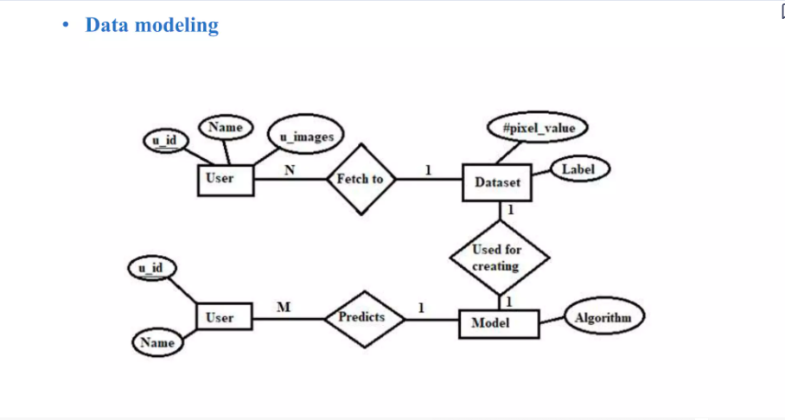

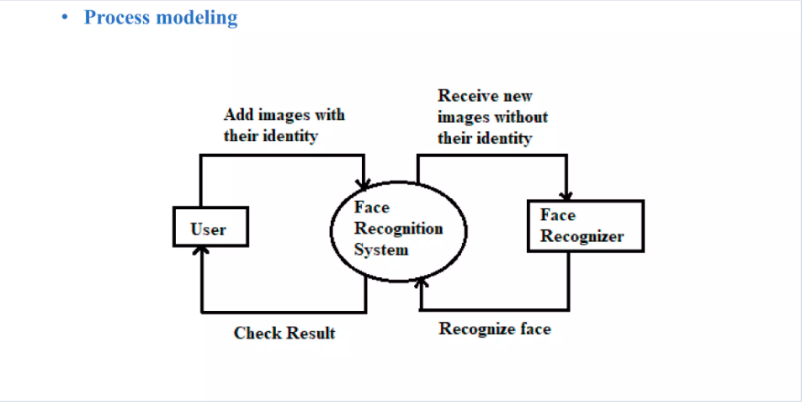

**3.2 File Structure**

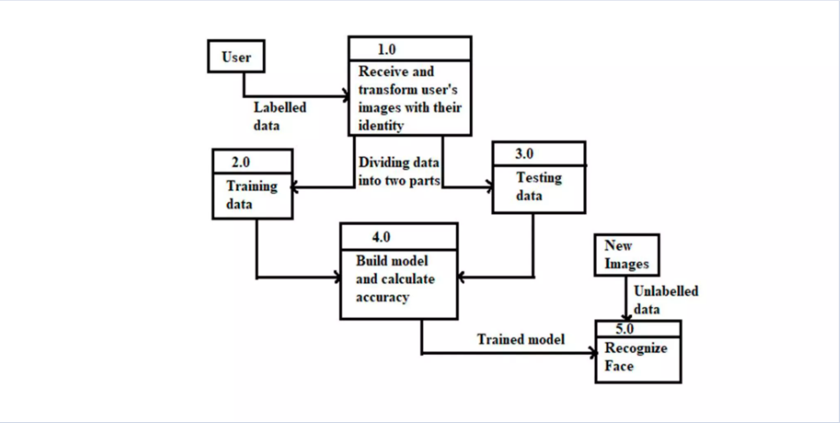

**3.3 Algorithms used:**

* Haar Cascade Classifiers: These are a type of machine learning-based object detection algorithm used for face detection. They work by identifying features (like edges, corners, etc.) of objects in images. Haar cascade classifiers have been widely used due to their simplicity and efficiency in detecting faces in images.
* Histogram of Oriented Gradients (HOG): HOG is a feature descriptor technique used for object detection. It works by calculating histograms of gradient orientations in localized portions of an image. HOG has been utilized in facial recognition systems for feature extraction from facial images.
* Convolutional Neural Networks (CNNs): CNNs are a type of deep learning algorithm particularly well-suited for image processing tasks. They consist of multiple layers of convolutional filters and have demonstrated exceptional performance in tasks such as image classification, object detection, and facial recognition. Architectures like VGG, ResNet, and MobileNet are commonly used for feature extraction and classification in facial recognition systems.
* Eigenfaces: Eigenfaces is a classic algorithm used for facial recognition, based on principal component analysis (PCA). It works by representing faces in a lower-dimensional space spanned by the principal components (eigenvectors) of a dataset of facial images. Eigenfaces are then used to reconstruct and recognize faces.
* Local Binary Patterns (LBP): LBP is a texture descriptor algorithm commonly used in facial recognition for feature extraction. It encodes the local texture patterns of an image by comparing the intensity of each pixel with its neighboring pixels. LBP has been shown to be effective in capturing facial texture information.
* Siamese Networks: Siamese networks are a type of neural network architecture used for one-shot learning and similarity comparison tasks. In facial recognition, Siamese networks learn to measure the similarity between two facial images and are used for verification or identification tasks.
* Deep Metric Learning: Deep metric learning algorithms are used to learn embeddings that map facial images into a high-dimensional feature space where similar faces are clustered together. Techniques like contrastive loss, triplet loss, and center loss are commonly used for training deep metric learning models in facial recognition systems.
* Support Vector Machines (SVMs): SVMs are a supervised learning algorithm used for classification tasks. In facial recognition, SVMs are often used as classifiers to distinguish between different individuals based on extracted facial features.

These algorithms can be combined and adapted to suit the specific requirements and constraints of a facial recognition project, such as computational efficiency, accuracy, and scalability.

The development of a face recognition system involves the implementation of various algorithms for different stages of processing, including face detection, feature extraction, and recognition. Below are some of the key algorithms commonly used in each stage:

#### 1. Face Detection Algorithms

**Viola-Jones Algorithm**:

* Utilizes Haar-like features and a cascade classifier to detect faces in images.
* Efficient and widely used for real-time face detection.

**Histogram of Oriented Gradients (HOG)**:

* Computes histograms of gradient orientation in localized regions of an image.
* Combined with a linear SVM classifier to detect objects, including faces.

**Deep Learning-based Detectors**:

* Convolutional Neural Networks (CNNs) trained specifically for face detection, such as:
  + **Single Shot Multibox Detector (SSD)**
  + **Region-based Convolutional Neural Networks (R-CNN)**
  + **YOLO (You Only Look Once)**

#### 2. Feature Extraction Algorithms

**Eigenfaces**:

* Principal Component Analysis (PCA) applied to a dataset of face images to extract eigenfaces.
* Represents faces as linear combinations of eigenfaces for dimensionality reduction and feature extraction.

**Local Binary Patterns (LBP)**:

* Describes texture patterns in an image by comparing each pixel with its neighbors.
* Used to extract texture-based features from facial regions.

**Deep Learning-based Feature Extractors**:

* Convolutional Neural Networks (CNNs) trained for facial feature extraction, including:
  + **VGGFace**
  + **ResNet**
  + **Inception**

#### 3. Face Recognition Algorithms

**Eigenfaces with Nearest Neighbor Classifier**:

* Eigenfaces used for dimensionality reduction, followed by nearest neighbor classification for recognition.

**Fisherfaces**:

* Linear Discriminant Analysis (LDA) applied to face images to maximize class separability.
* Similar to Eigenfaces but focuses on discriminative features.

**Local Binary Patterns Histograms (LBPH)**:

* Computes histograms of Local Binary Patterns from facial regions.
* Uses histogram comparison methods like Chi-squared distance for recognition.

**Deep Learning-based Approaches**:

* Siamese Networks:
  + Learns embeddings of face images in a high-dimensional space, where similar faces are closer together.
* Triplet Loss:
  + Trains networks to minimize the distance between images of the same person (anchor and positive) while maximizing the distance between images of different people (anchor and negative).

#### 4. Post-processing Algorithms

**Face Alignment and Normalization**:

* Algorithms such as Procrustes analysis or affine transformations to align facial landmarks for improved recognition accuracy.

**Quality Assessment**:

* Techniques to evaluate the quality of detected faces and discard low-quality or irrelevant detections.

**Privacy-Preserving Techniques**:

* Secure multiparty computation, homomorphic encryption, or differential privacy for protecting sensitive information during face recognition.

#### 5. Performance Optimization Algorithms

**Parallelization**:

* Techniques like multi-threading or GPU acceleration to speed up computation-intensive tasks.

**Model Quantization**:

* Reducing the precision of model parameters to lower memory and computational requirements.

**Model Pruning**:

* Removing redundant or less important connections in neural network models to reduce model size and computational cost.

These algorithms can be combined and customized based on the specific requirements and constraints of the face recognition system, such as accuracy, speed, and resource availability. Additionally, advancements in deep learning and computer vision continue to drive the development of more efficient and accurate algorithms for face recognition tasks.

Top of Form

**4.Results**

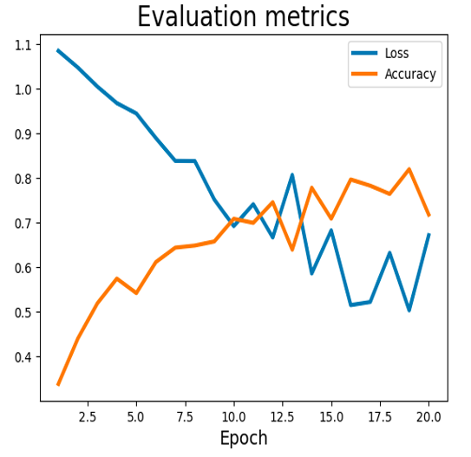



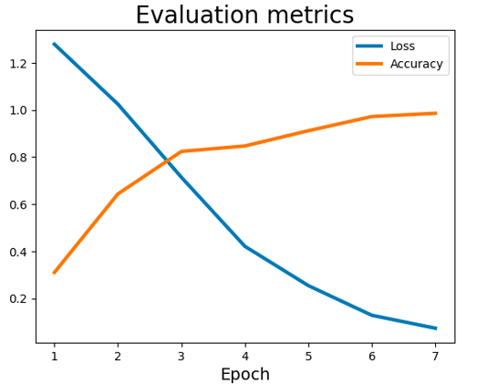



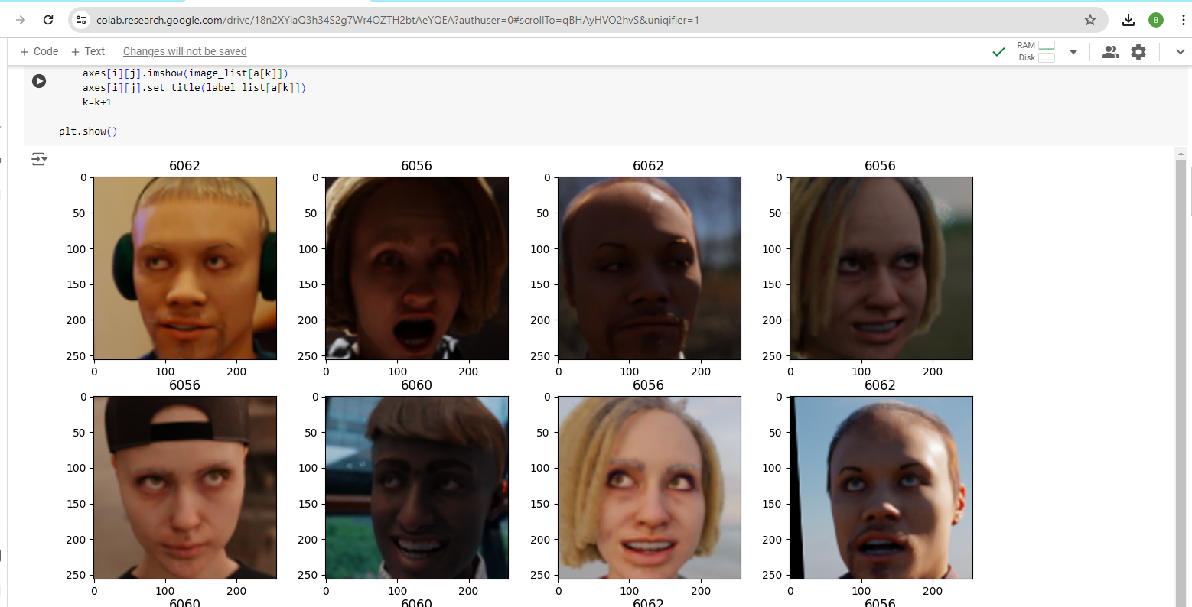

**5.References**

* [www.w3scools.com](http://www.w3scools.com)
* [www.javapoint.com](http://www.javapoint.com)
* [www.technopedia.com](http://www.technopedia.com)
* [www.Wikipedia](http://www.Wikipedia)
* [www.techtarget.com](http://www.techtarget.com)